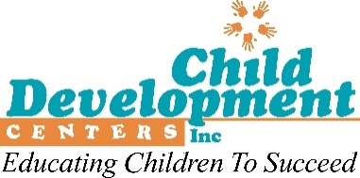

**Please return completed gift form to your Center Director by Friday, Dec. 13.**

**CDC GIFT FORM**

Donor Name: ________________________________ Your Center _______________________

Address: ____________________________________________ City: _______________________

State: ___________ Zip: ______________

□ I wish my gift to remain anonymous. Please do not publish my name in the CDC newsletter/annual report.

**□ Please accept the enclosed personal check or cash contribution in the amount of $_____________.**

*(Make checks payable to Child Development Centers, Inc., and write “Annual Appeal” on the memo line.)*

**□ I wish to give online in the amount of $ __________.** *(To give online, visit the Annual Appeal landing page on the CDC website at* [*https://www.cdcenters.org/give/staff.html*](https://www.cdcenters.org/give/staff.html)

**□ I wish to make a bi-weekly gift by payroll deduction. Please deduct $ __________ (at least $1) from my pay every payday for 26 pay periods until Dec. 31, 2025.** My total gift will be $_____________.

**□ I wish to make no further contributions. If I currently give by payroll deduction, please discontinue my current bi-weekly gift after December 31, 2024.**

Please use my gift for:

□ Children’s Foundation of CDC

□ CDC Food Program

Please make my gift in honor of _____________________________.

Please make my gift in memory of ____________________________.

Send acknowledgement of my honorary/memorial gift to:

Name: ________________________________

Address:_______________________________________

City:______________________ State: _________ Zip:______________

**All Donors:** *I understand that my gift is federal income-tax deductible if I itemize deductions. I also understand that, unless I indicate otherwise above, my gift will be acknowledged in a future edition of Child Development Centers’ newsletter/annual report.*

*______________________________________ ___________________________________*

Signature Date

*Child Development Centers, Inc. (CDC) is registered as a 501(c)(3) non-profit organization. Contributions to CDC are tax-deductible to the extent permitted by law.*

*The official registration and financial information of Child Development Centers, Inc. may be obtained from the Pennsylvania Department of State by calling toll-free within Pennsylvania, 1-800-732-0999. Registration does not imply endorsement.*

*Child Development Centers, Inc. Tax ID No.: 25-1198158*